Guide to Working From Home for Graduate/Postdoctoral Researchers

With COVID19, everyone is asked to stay home and practice social distancing, but at the same time encouraged to continue research activities from home and conduct work remotely. This way of working is unfamiliar to many of us. The following guide aims to give you some ideas about how to work from home while maintaining your well-being, what types of tasks you may want to focus on, and what resources are still available for you.

The following are adapted from advice given by mental health specialists and academics, many of whom are on social media; with additional thoughts/ideas contributed by Samantha Cheung, Arthur Chan, and Christine Romano. A full list of the original sources can be found at the end of this document.

How to work from home

First, go easy on yourself; we’re in a global pandemic and it’s very much not business as usual. Everyone is anxious and scared. Expecting high productivity is expecting too much.

Prioritise your physical and mental health. This could involve practicing mindfulness, limiting your intake of news, cleaning up your social media feed, spending time away from a screen, and taking care of those around you.

Try to carve out a space in your home that’s just for work. A desk/table/room where you can maintain a setup only for work, if possible. Try to make this space be far from where you sleep and well-lit. This helps you to have a dedicated space for your virtual meetings/online lectures and a way to create a physical boundary between your working hours vs. non-working hours.

Fall into routine and make a schedule: Get up, shower, get dressed, brush your teeth, eat breakfast—do your regular morning routine. Then go to your working space, just as though you’re heading to campus. The routine is very helpful for getting into work mode; experiment with what feels the most comfortable and productive.

Take breaks! Often! Get up from your workspace and read, hang out with your pets, watch an episode of your favorite TV show, nap, play a game, paint your nails. Recognize when you’re cognitively loaded and not working well, then step away from work for a bit.

Use the same social support structures you would normally use to stay sane. Stay connected with your friends with texts, phone/video calls. Access online resources (below). Stay in touch with your PI and lab mates on a weekly basis. Social distancing does not mean social isolation. You can use free online tools such as WhatsApp, Slack, Skype, or Zoom.

Lastly, recognize that this is new territory. Do the best you can with working from home, but if you’re trying and still aren’t able to get stuff done, that’s ok. It might take a while. It might be impossible. It’s ok. It’s hard to be productive right now. Do what you can.

What to work on from home

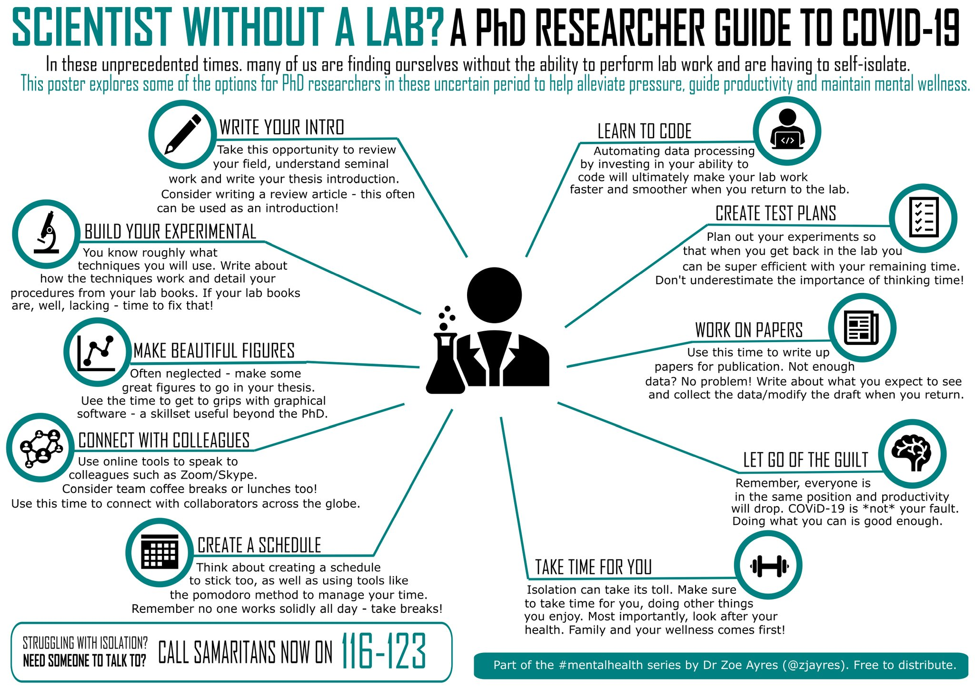
Source:https://twitter.com/ZJAyres/status/1239983524259737606/photo/1

Refocus on tasks that you can do from home, and table everything else. These will likely be different in nature from what you have done before. Write, do literature reviews, read papers, craft detailed experimental plans, do math, do simulations. You’re more likely to have successful physical tests if you spend more time on the fuzzy front end of the process-the research, understanding, and ideation phases.

Use productivity tools. There are many techniques to help you with goal-setting, focusing on writing, motivation etc.; some of which are summarized here. Another useful thing to do is to form writing accountability groups (virtually), where you set writing goals and timelines with other people (could be within or outside your lab group). Not only can you help each other meet writing goals, you also maintain contact with other people and won’t feel as isolated.

Other productive things you can do: https://www.sciencemag.org/careers/2020/03/working-home-because-covid-19-here-are-10-ways-spend-your-time

List of references on which this guide is based:
Prof. Bryony DuPont on working from home during COVID: https://twitter.com/BryonyDuPont/status/1239945140229173248
Prof. Jenny Yang on productivity tools: https://twitter.com/icjennikins/status/1240381716797067265
Dr. Zoe Ayres on working from home during COVID: https://twitter.com/ZJAyres/status/1239983524259737606/photo/1
Writing Accountability Groups: https://www.insidehighered.com/advice/2010/06/14/shut-and-write

Useful Resources/Links at U of T:
My SSP
My Student Support Program (MySSP) provides University of Toronto students with immediate and/or ongoing confidential, 24-hour support for any school, health, or general life concern at no cost to students. You can call or chat with a counsellor directly from your phone whenever, wherever you are for a range of concerns.

Student Life
Events/Workshopshave been cancelled or postponed for the remainder of the term, but they still have many services available online or by phone:
The Centre for International Experience - addressing the needs for International Students
Graduate Conflict Resolution Centre - Peer-to-peer chats, big or small!
Academic Success
Accessibility Services
And more!

Accessibility Services
Moving courses to an online format can affect students with accommodations. The Accessibility Services team is available via phone and email, and is posting updates as they become available.

SGS Emergency Grant:
Emergency assistance grants are available for domestic and international students impacted by COVID-19 and who need immediate short-term financial relief because of unexpected expenses.

GECoS Mental Wellness Commission
The Engineering Graduate Student Mental Wellness Commission Facebook Group shares resources, tips, and events (in the future) for UofT engineering grad students.

Additional Resources
A list of UofT and Community mental health resources and contacts from the Student Life Website.

UofT Central Hub
For most up to date information and resources on COVID-19.

School of Graduate Studies website
Updated information relevant to the graduate community during the COVID-19 outbreak. Information on academic activities, final oral examinations and more can be found on this site.

Community-Wide Mental Health Resources:
Some of the above campus-based resources may only be open to students and not post-docs. Here’s a list of Toronto community resources that are available to the general public:

Skylark Foundation.
https://www.skylarkyouth.org/

Toronto New Life Wellness Place
https://www.newlifeplace.ca/

What’s Up Walk In
https://www.whatsupwalkin.ca/

Progress Place Warm Line
http://warmline.ca/

Toronto Distress Center
https://www.torontodistresscentre.com/

If you have any questions/concerns about this Guide, please contact:

Arthur Chan (arthurwh.chan@utoronto.ca)
Christine Romano (romano.christine@gmail.com)
Samantha Cheung (samantha.cheung@mail.utoronto.ca)

